

K.L.E. SOCIETY’S
P.C. JABIN SCIENCE COLLEGE,
AUTONOMUS,
(Affiliated to KARNATAK UNIVERSITY, DHARWAD)
HUBBALLI -580031
Bachelor of Computer Application
2025-26

A Dissertation Report
On

AI POWERED STUDENT PERFORMANCE TRACKER
Submitted in partial fulfillment of the requirement for the award of the degree

BACHELOR OF COMPUTER APPLICATION

Submitted By

Madhav P Amruth Badi Guruprasad Charati
223204 223183 223196

Under The Guidance Of Prof. SONIYA G.

Affiliated to
Karnatak University, Dharwad.

CERTIFICATE

This is to certify that the project entitled AI STUDENT PERFORMANCE TRACKER is a Bonafide work carried out by the student team Mr. Madhav P – Reg No 223204 and Mr. Amruth Badi -Reg No 223183, Mr. Guruprasad Charati - Reg No 223186 in partial fulfillment of the award of degree of Bachelor of Computer Application during the year 2025 – 2026. The project report has been approved as it satisfies the academic requirement with respect to the project work prescribed for the award of BCA Degree.

__________________ _____________
Guide HOD

External Examination:

Name of the Examiners Signature with date
1.

2.

DECLARATION

We hereby declared that the project report entitled AI STUDENT PERFORMANCE TRACKER, submitted in fulfillment of requirement of BCA V Semester Project work for the award of Degree in Bachelor of Computer Application of KARNATAK UNIVERSITY, Dharwad during the academic year 2025-26.
We further declare that this project report is the result of our original work and has not been submitted to any other organization or institute for the award of any degree or diploma.

Date: 15/12/2025
Place: Hubballi

Sign (Amruth Badi)

Sign(Guruprasad Charati)

Sign(Madhav P)

ACKNOWLEDGEMENT

It’s our pleasure to thank all the individuals who have directly or indirectly helped and motivated us in the fulfilment of completion of the project work.
We thank Prof. Siddalingappa Kadakol, HOD, KLE Society’s BCA, P C Jabin Science College, HUBBALLI for having given us all encouragement and motivation for making this project work successful.
We thank our guide Prof. Soniya G., KLE Society’s BCA, P C Jabin Science College, HUBBALLI for giving us valuable suggestions and guidance for our project work, which are the background of the project.
Our gratitude also goes to all Teaching and Non-Teaching staff of KLE Society’s BCA, P C Jabin Science College, HUBBALLI who have helped us in completing this project work.
Finally, we would like to thank our family and friends for their constant motivation and inspiration that kept us going.

Sign (Amruth Badi)

Sign(Guruprasad Charati)

Sign(Madhav P)

ABSTRACT

Traditional educational tracking systems predominantly rely on reactive metrics, identifying student failure only after major examinations have occurred. This retrospective approach often leaves students without the support they need at critical junctures of their academic journey. When educators rely solely on semester-end grades, the opportunity for proactive, corrective intervention is already lost. This dissertation introduces the "AI-Powered Student Performance Tracker," a sophisticated, full-stack web application designed to proactively predict both academic scores and burnout risk levels well before formal examinations take place.

By engineering a comprehensive 10,000-record dataset that merges core academic metrics (such as attendance and study hours) with critical lifestyle and physiological factors (such as sleep patterns, mental health scores, screen time, and caffeine intake), we trained robust Machine Learning models to forecast academic outcomes with high reliability. The core predictive engine utilizes a dual-model approach using the Random Forest algorithm: a Regressor for continuous score prediction and a Classifier for risk level categorization.

However, in the context of education, predictive accuracy alone is insufficient; algorithmic transparency is paramount. To solve the "Black Box" problem inherent in modern Machine Learning, SHapley Additive exPlanations (SHAP) were integrated into the architecture. This cooperative game theory approach allows the system to generate mathematically exact explanations of each individual feature's contribution to a student's final prediction. Consequently, students receive actionable feedback (e.g., "Your score is reduced by 8% due to insufficient sleep"), empowering them to make specific lifestyle changes.

The system is deployed via a decoupled, service-oriented architecture. The frontend is built using React.js (via Vite) and Tailwind CSS, offering a highly responsive, glassmorphism-inspired UI. The backend is powered by Python and the Django REST Framework (DRF), which securely handles JWT authentication, PostgreSQL database operations (via Supabase), and the complex matrix transformations required for real-time ML inference. The ultimate goal of this project is to provide a digital "safety net" that catches at-risk students proactively, enabling personalized interventions, fostering mental wellbeing, and ultimately improving academic success rates across educational institutions.

CONTENTS

Slno Topic Page No
- Introduction 1
- Literature Survey 4
- Technical Requirements 7
- Project Description 9
- System Design ¹²
- UI Design And Outputs ¹⁷
- Implementation ¹⁹
- Test Case ³⁷
- Conclusion ⁴³
10. Future Enhancement 44
11. Bibliography ⁴⁵

I. INTRODUCTION

1.1 Overview

In today’s ruthlessly competitive academic climate, the strain placed upon students has surged to unprecedented levels. Modern higher education settings necessitate constant cognitive labor, frequent examinations, and high-stakes peer rivalry. While colleges prioritize syllabus completion and testing, they frequently lack the necessary infrastructure to track the multifaceted, personal elements that truly govern a learner’s academic trajectory.

For many years, the scholastic world viewed performance as a static, isolated variable, detached from a student’s physical and emotional health. Yet, contemporary data confirms that psychological stability, rest cycles, digital screen engagement, and personal study discipline are far more influential than simple classroom presence in determining final results.

The digitalization of learning has produced immense datasets that often remain trapped in isolated silos like grade sheets and attendance logs. The AI-Powered Student Performance Tracker marks a major technical transition from reactive monitoring to a proactive paradigm. Rather than merely documenting failure after the fact, our system employs Machine Learning as a predictive radar, evaluating daily micro-habits to forecast exam outcomes and mental fatigue risks well before they manifest

Advantages of Project :-

- Shift from Reactive to Proactive Intervention :- Educators receive intelligence weeks in advance.

- Eradicating the AI "Black Box" :- SHAP provides mathematical breakdowns for undeniable proof.

- Massive Operational Scalability & Efficiency :- Hundreds of predictions generated in seconds via CSV.

- Holistic Focus on Mental Wellbeing :- Validates mental health as a core academic predictor.

5 . Cost-Effectiveness :_ Native Python inference eliminates expensive external API costs.

1.2 Motivation

The drive for this research emerged from observing the modern student struggle, specifically regarding the global surge in mental health crises and attrition rates. Many individuals suffer in silence, hindered by poor time management and deteriorating wellbeing. Often, they do not realize that habits like substituting sleep with excessive caffeine or spending hours on social platforms are actively sabotaging their focus and memory retention.

Additionally, educators are frequently overwhelmed by massive student-to-teacher ratios, making it nearly impossible to manually track the lifestyle shifts of every individual. Most faculty only detect a crisis once a blank paper is submitted, by which point corrective intervention is no longer viable.

We sought to engineer a system that functions as a continuous digital mentor. By utilizing web technologies and data science, we aimed to automate the identification of these negative trends. Our goal was to build a supportive framework that avoids judgment, instead providing students the clarity and time needed to realign their academic journey.

1.3 Purpose

The core objective of the AI-Powered Student Performance Tracker is to equip both learners and administrators with real-time, evidence-based intelligence.

For the Student, the platform facilitates self-regulation. It serves as a digital mirror, illustrating how their daily routines will translate into future results. By inputting their lifestyle data, they gain an immediate, intelligent projection of their likely academic path.

For the Educator, the system enables efficient resource management. A central command interface allows faculty to monitor risk distribution across the institution, instantly highlighting high-priority cases that require immediate counseling or human intervention.

Furthermore, we aim to build trust in AI within the education sector. Through Explainable AI (XAI), our models do more than just predict; they provide mathematical justifications, showing exactly which lifestyle habits contributed to a specific outcome.

1.4 Scope of the Project

The scope of this project covers the entire Software Development Life Cycle (SDLC), from initial data engineering to final cloud deployment, including:

1. Data Synthesis: Developing a 10,000-record dataset that correlates behavioral features with academic performance.
2. ML Development: Training and fine-tuning Random Forest models to interpret non-linear human behavioral patterns.
3. Explainable AI: Integrating SHAP for reverse-engineering predictions into transparent impact percentages.
4. Backend Engineering: Building a Django REST API with JWT security, PostgreSQL models, and automated email verification.
5. UI/UX Design: Creating a responsive React.js frontend featuring Glassmorphism and interactive data visualizations.
6. Cloud Deployment: Orchestrating a decoupled architecture across Vercel, Render, and Supabase for high availability.

1.5 Problem Statement

"Current academic management platforms are fundamentally retrospective. They analyze past grades but ignore the real-time behavioral and physiological data that dictates future success. Institutions consequently lack a transparent, proactive warning system to identify students heading toward failure or burnout before their final examinations."

1.6 Proposed Solution

To address these shortcomings, we propose a Full-Stack Web Application featuring a natively embedded Machine Learning inference engine.

The architecture consists of two primary modules. The Student Portal enables users to log daily habits which are then processed by our backend models to predict scores and risk levels. SHAP values are visualized to ensure users understand the causal links in their data. The Admin Portal offers faculty a macro-overview, allowing for bulk data uploads and targeted identification of at-risk students for proactive academic counseling.

II. Literature Survey

2.1 Evolution of Educational Data Mining (EDM)
Early literature in EDM focused on predicting GPA using demographic data and historical grades. These autoregressive models failed to capture a "sudden dip" in a student's performance caused by non-academic issues like insomnia or gaming addiction, as they only relied on past grades.

2.2 The Shift Toward Physiological and Behavioral Features
Recent empirical studies show that student success is heavily influenced by physiological and behavioral factors such as sleep quality, screen time, mental health scores, and burnout indices. The project incorporates 14 distinct features, ranging from caffeine_intake to gaming_hours and mental_health_score, into the predictive pipeline to bridge the gap between medical/psychological understanding and university software.

2.3 Review of Machine Learning Algorithms in Education
We evaluated several algorithms, ultimately selecting Random Forest. Multiple Linear Regression (MLR), Support Vector Machines (SVMs), and Deep Learning (Neural Networks) were rejected due to issues with non-linearity, high computational cost/interpretability, or the risk of overfitting/creating a "Black Box".

2.4 The "Black Box" Problem and Explainable AI (XAI)
To provide ethical transparency in this high-stakes environment, we integrated SHapley Additive exPlanations (SHAP). SHAP is grounded in cooperative game theory, enabling the system to generate mathematically exact explanations of each feature’s contribution to the final prediction, ensuring transparent, actionable advice.

2.5 Existing System vs. Proposed System
The proposed system shifts the paradigm from :-

- Approach: Reactive (action after failure) to Proactive (action before potential failure).

- Data Scope: Strictly Academic to Holistic (Academic + Sleep, Screen Time, Mental Health).

- Explainability: N/A to High, using SHAP to generate localized feature impact graphs.

2.6 Academic Analytics and Student Productivity Factors

Academic analytics involves leveraging institutional data to understand and optimize student learning and institutional processes. While Educational Data Mining (EDM) is a subset focused on methodologies, academic analytics is the broader application of these findings to create actionable strategies. Our project moves beyond descriptive reporting by focusing on prescriptive analytics, recommending courses of action to improve predicted outcomes.

The theoretical underpinning of our feature selection is the acknowledgement of Student Productivity Factors (SPF). SPF theory posits that a student’s output (academic score) is a non-linear function of inputs related to three domains: cognitive, behavioral, and physiological.

- Cognitive Factors: Directly related to learning (e.g., study_hours, class_participation).

- Behavioral Factors: Habits influencing academic application (e.g., social_media_hours, gaming_hours, part_time_job).
- Physiological Factors: Biological states critical for memory and focus (e.g., sleep_hours, mental_health_score, caffeine_intake).

The integration of these factors ensures the model captures the holistic student profile, allowing the system to identify complex trade-offs, such as a student attempting to compensate for low sleep with high caffeine intake, a behavior which often results in diminished long-term cognitive function.

2.7 Risk Prediction Theory and Student Burnout Prediction

Risk prediction in the educational context is defined as the automated identification of learners whose current trajectory places them in the bottom quartile of expected performance or whose psychological metrics indicate high probability of dropout or severe stress. This utilizes classification models to move beyond simple score prediction (regression).

The concept of Student Burnout is critical. Maslach and Leiter defined burnout as having three dimensions: exhaustion, cynicism, and reduced personal accomplishment. Our system predicts burnout risk indirectly by correlating high-risk predictions with input features that are clinically associated with academic stress, such as low mental_health_score and high total_screen_time combined with high upcoming_deadlines.

The Random Forest Classifier component specifically targets this risk prediction. By training the classifier on labeled data (mapping input habits to a risk class: Low, Medium, High), the model learns the complex decision boundaries that delineate a stable student from one in crisis. This dual-model approach (Regressor for score, Classifier for risk) provides a robust and multifaceted diagnostic outcome for counselors.

2.8 Deep Dive into the Random Forest Algorithm

The selection of the Random Forest ensemble method is rooted in its proven resilience against the noisy, multi-dimensional data characteristic of human behavior. Random Forest operates on the principle of Bootstrap Aggregation (Bagging) and Feature Randomness.

- Bagging: Multiple subsets of the original 10,000-record dataset are created by sampling with replacement. A unique decision tree is trained on each subset. This diversity prevents any single tree from dominating the overall prediction (reducing variance).

- Feature Randomness: During the construction of each tree, only a random subset of the total 14 features is considered at each split point. This enforces low correlation between individual trees, ensuring that the ensemble is not overly reliant on one powerful feature (e.g., attendance) but considers the holistic interplay of all factors.

For the Random Forest Regressor, the final predicted score is the mean of the scores predicted by all individual trees. For the Random Forest Classifier, the final risk level is determined by a majority vote among all trees. This ensemble approach provides a highly stable and accurate prediction, essential for a high-stakes application like educational guidance. The model's inherent ability to calculate Feature Importance is a natural precursor to the more sophisticated SHAP integration.

III. Technical Requirements

3.1 Hardware Requirements
- Processor: Intel Core i3 (10th Gen) or AMD Ryzen 3 equivalent.

- Memory (RAM): 8 GB Minimum (16 GB Recommended for training ML models).

- Storage: 500 MB minimum free space for source code and dependencies.

- Network: Stable internet connection for Cloud Database integration.

3.2 Software Requirements

- Operating System :- Cross-platform compatibility including Windows 10/11, macOS Monterey+, or Ubuntu 20.04+ (development was conducted primarily on Windows via PowerShell).

- Backend Environment :- Python 3.11.x runtime for server-side logic and machine learning inference.

- Frontend Runtime :- Node.js (v18.x or v20.x LTS) with npm for package management and building the UI.

- Database System :- PostgreSQL (v15+) hosted remotely through Supabase cloud services.

- IDE & Tools :- Visual Studio Code utilizing extensions for Python, Tailwind, and ESLint, along with Git for version control.

- Web Browser :- Modern versions of Chrome, Firefox, or Edge with V8 JavaScript engine support.

3.3 Technology Stack Deep-Dive & Justification

3.3.1 Backend: Django & Django REST Framework (DRF)

Python was chosen as the primary backend language due to its unparalleled dominance in the data science landscape. Integrating Scikit-Learn models into other runtimes is inefficient; thus, using Python allows ML inference to occur natively within the API memory space. We opted for Django over lighter frameworks to leverage its comprehensive architecture, including secure authentication and robust ORM. DRF was integrated to facilitate seamless serialization of complex model outputs for the frontend.

3.3.2 Frontend: React.js & Vite

React.js serves as the presentation layer, utilizing a component-based model for highly reusable UI elements. The virtual DOM facilitates smooth updates of interactive dashboard visualizations without full page reloads. We utilized Vite to leverage native ES modules, ensuring lightning-fast server startup times and near-instantaneous hot module replacement, which significantly accelerated the UI development cycle.

3.3.3 Database: Supabase (PostgreSQL)

The project employs Supabase for its managed PostgreSQL capabilities, ensuring high scalability and reliability. PostgreSQL was favored over non-relational alternatives because user records and performance predictions necessitate rigid relational data integrity and structured querying requirements.

3.3.4 Machine Learning & Data Science Libraries

- Scikit-Learn :- Employed for the training of RandomForest models to interpret human behavioral patterns.

- Pandas & NumPy :- Utilized for data cleaning, manipulation, and complex matrix transformations.

- SHAP :- Crucial for initializing TreeExplainers to demystify algorithmic decisions into transparent feedback.

- Joblib :- Used to serialize trained models into lightweight files for instant loading by the Django server.

3.3.5 Styling & UI Libraries

- Tailwind CSS (v4) :- A utility-first framework providing responsive design capabilities and the modern Glassmorphism aesthetic.

- Framer Motion :- Integrated to deliver fluid, declarative animations that enhance the overall user experience.

IV. Project Description

4.1 Methodology (Agile Development Lifecycle) :-

The engineering of the AI-Powered Student Performance Tracker was orchestrated following the Agile Software Development Methodology. Departing from the rigid constraints of the Waterfall model, Agile facilitated an iterative and incremental development cycle. This was particularly vital for the Machine Learning components, as achieving predictive reliability necessitated continuous recalibration and fine-tuning based on persistent testing. The project execution was divided into several high-intensity "Sprints":

Sprint 1 :- Data Engineering & Foundation (Weeks 1-2) :-

• Acquired the "Student Performance Dataset" and "Ultimate Student Productivity Dataset" from Kaggle repositories.
• Executed rigorous data sanitization, managing null values and synthesizing a unified 10,000-record dataset.

• Established the GitHub repository and initialised the foundational Django and React architectural frameworks.

Sprint 2:- Machine Learning Pipeline (Weeks 3-4) :-

• Partitioned the synthesised data into an 80/20 ratio for training and validation sets.
• Evaluated multiple architectures, ultimately selecting and optimising the Random Forest algorithms.

• Configured the SHAP TreeExplainer and serialised the finalised models utilising joblib.

Sprint 3:- Backend API & Security (Weeks 5-6) :-

• Formulated the PostgreSQL schema and generated the corresponding Django models.
• Configured JSON Web Token (JWT) authentication for stateless session security.
• Integrated Brevo SMTP to manage automated OTP generation for secure registration and credential recovery.

• Developed the /predict endpoint to bind ML inference to live HTTP traffic.

Sprint 4 :- Frontend UI & Integration (Weeks 7-8) :-

• Developed React components with Tailwind CSS, emphasizing a sophisticated glassmorphism aesthetic.

• Engineered the Student Dashboard featuring interactive visualizations for SHAP impact metrics.

• Constructed the Admin Command Center with support for pagination and batch CSV processing.
• Established connectivity between the UI and Django backend via Axios interceptor middleware.

Sprint 5 :- Testing & Cloud Deployment (Weeks 9-10) :-

• Executed comprehensive Unit, Integration, and User Acceptance Testing phases.
• Optimized CORS configurations and environment variables for production environments.

• Deployed the backend API to Render and the SPA to the Vercel Edge Network.

4.2 Functional Requirements

Functional requirements delineate the essential capabilities and features the system must execute to address user objectives.

1. Authentication & Authorization Module:-
• The system must enable user registration with mandatory email verification via a 6-digit OTP.\
• Support for two distinct hierarchical roles, Student and Admin, is required.
• Secure password reset functionality must be facilitated through encrypted email links.

2. Student Data Entry Module:-

• A centralized interface must be provided for students to input exactly 14 behavioral and academic metrics.

• Rigid validation logic must ensure all inputs (e.g., sleep duration) remain within logical physiological limits.

3. Machine Learning Inference Module :-
• Upon submission, data must be processed through the Random Forest inference engine.
• The system shall calculate a predicted scholastic score between 0.0 and 100.0.
• Students must be categorized into Low, Medium, or High risk levels.
• Generation of a JSON object containing SHAP impact values for all features is mandatory for transparency.

4. Student Dashboard Module :-

• The platform must present the latest prediction in an intuitive, high-fidelity visual format.
• Dynamic charts must be rendered to illustrate specific lifestyle drivers of the predicted outcome.

• A historical trend analysis must be available to track performance fluctuations over time.

5. Admin Command Center Module:-
• Administrators require a searchable, paginated overview of all students and their respective risk levels.
• Filtering capabilities must allow for the immediate identification of vulnerable cohorts.
• Bulk operations via .csv uploads must enable batch prediction generation for entire institutions.
• Tracking mechanisms for system accuracy must be available via actual score reconciliation.

4.3 Non-Functional Requirements

Non-functional requirements specify the operational criteria and constraints governing system behavior and performance quality.

1. Performance and Latency:
Despite the computational overhead of ML inference, end-to-end response times must not exceed 2.0 seconds to maintain high user engagement.

2. Scalability:
The decoupled framework must support infinite scaling on the Vercel CDN, while the backend must process batch uploads of up to 500 records without service interruption.

3. Security and Privacy :-
• Cryptographic hashing utilizing the PBKDF2 algorithm is mandatory for all stored passwords.
• Protected endpoints must require valid JWT Bearer tokens with short-term expiration and refresh cycles.
• Role-Based Access Control (RBAC) must strictly isolate student data from unauthorized administrative access.

4. Usability: The UI must be fully responsive across desktop, tablet, and mobile displays, utilizing clear typography and high-contrast modes for accessibility.

5. Reliability: Leveraging managed cloud services ensures a target availability uptime of 99.9%.

4.4 Feasibility Study

A rigorous feasibility assessment was conducted across three critical dimensions to validate the viability of the proposed solution :-

• Technical Feasibility (High):
The architecture leverages stable, open-source technologies including Scikit-Learn and Django. The team possesses expertise in full-stack development and data science, ensuring no integration bottlenecks.
• Economic Feasibility (High):
By optimizing free tiers on Vercel, Render, and Supabase, the system achieves production-grade deployment with zero financial overhead. Native ML execution avoids the high costs associated with proprietary AI APIs.

• Operational Feasibility (High):
The platform addresses the critical challenge of academic burnout. An intuitive interface ensures minimal training requirements for students, while automated analysis saves administrative labor, making institutional adoption highly viable.

V. System Design 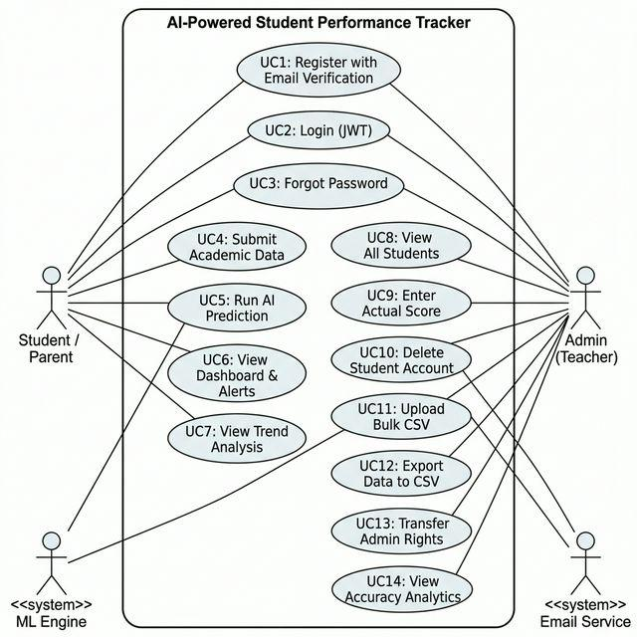

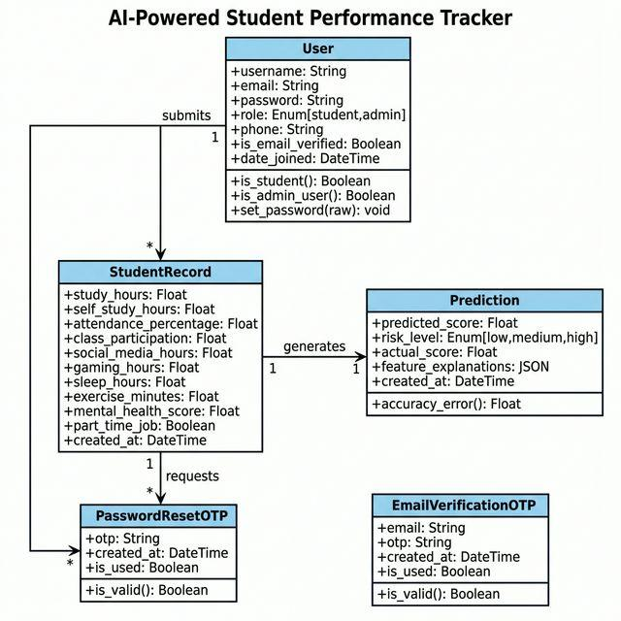

The architectural design phase is instrumental in establishing the fundamental structure, modular components, and data interfaces required to satisfy complex system prerequisites, effectively serving as the technical blueprint for subsequent development cycles.

5.1 Architecture Design (3-Tier Decoupled Architecture)

The platform eschews conventional monolithic frameworks in favor of a sophisticated, Decoupled 3-Tier Architecture. This deliberate separation of concerns ensures the presentation layer remains independent of the intricate Machine Learning computational logic.

1. Client Tier (Presentation Layer) :

• Orchestrated utilizing React.js and the Vite build tool.
• Executes natively within the user’s web environment.

• Governs UI rendering, local state management via Context API, and asynchronous HTTP communication through Axios.

2. Application Tier (Business & Logic Layer):

• Powered by Python and the Django framework, hosted on Render cloud services.
• Operates as the central engine, processing incoming JSON payloads from the client.
• Manages JWT verification, role-based permissions, and the routing of data through serialized Random Forest models for real-time inference.

3. Data Tier (Persistence Layer) :-

• Managed via Supabase, utilizing a robust PostgreSQL engine.
• Securely archives relational data, utilizing the Django ORM to abstract SQL operations and mitigate injection vulnerabilities.

5.2 Database Design and Schema

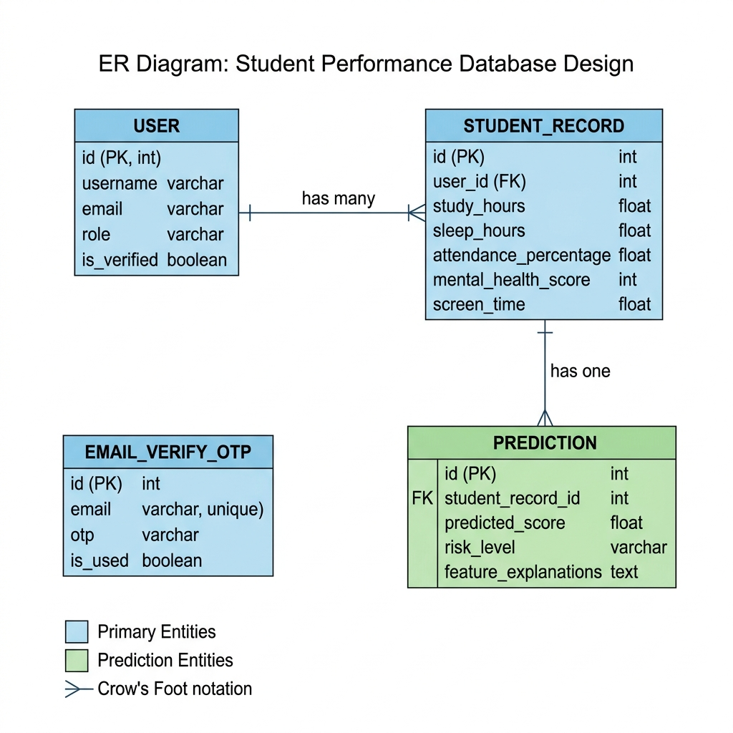

The relational architecture has been rigorously normalized to maintain data integrity. The primary schema includes:

1. core_user Table: Manages identity data, including unique credentials, hashed passwords, and hierarchical roles (student/admin).

2. students_studentrecord Table: Captures 14 critical behavioral and academic variables, such as attendance, study duration, and mental health metrics.

3. predictions_prediction Table: Stores ML-generated scores, risk levels, and SHAP-based feature justifications for actionable student feedback.

4. core_emailverificationotp Table: Handles transient security tokens for verified registration workflows.

5.3 Object-Oriented Analysis (OOA)

The system is modeled as a network of interacting objects, leveraging core OOA principles:

• Encapsulation: The StudentRecord object integrates diverse habit metrics, shielding the underlying database complexity.
• Inheritance: Custom User entities extend Django’s AbstractUser to inherit secure authentication while adding specific role attributes.
• Polymorphism: API endpoints process varying HTTP methods to facilitate both data retrieval and predictive inference.

5.4 System Interaction Scenarios

Scenario 1: Learner Metric Entry & Predictive Intelligence

This operational flow commences when a verified student submits daily routine variables. The architecture executes strict validation before engaging the Random Forest regressor, leveraging SHAP to provide granular feedback. The resulting scholastic projection is then rendered dynamically on the user's personal interface.

Scenario 2: Institutional Bulk Analysis via CSV

Faculty members are empowered to conduct high-volume performance audits by uploading structured datasets. Utilizing the computational power of Pandas, the backend executes simultaneous matrix calculations, instantly populating the administrative portal with comprehensive risk evaluations for large student cohorts.

5.5 Sequential Workflow and Information Pipeline

The intelligence gathering process in this system is governed by a rigorous technical sequence, ensuring both data precision and minimal latency during the prediction cycle. This sophisticated pipeline is structured into four distinct stages: Information Harvest, Algorithmic Execution, Interpretability Synthesis, and Visual Output.

5.5.1 Information Harvesting and Integrity Verification

The cycle initiates at the Client Tier, where users input 14 specific lifestyle indicators. The React frontend implements immediate integrity checks to prevent illogical entries, such as impossible sleep durations. Once validated locally, the data is transmitted as an encrypted JSON object to the Django REST backend for further processing.

5.5.2 Logic Layer Execution and Algorithmic Inference

Upon ingestion, the Django server verifies the session credentials and user permissions. The information is then mapped through a Serializer and archived within the PostgreSQL database. This data is subsequently transformed into a Pandas DataFrame structure, allowing it to be processed simultaneously by our pre-trained ensemble models :-

- Random Forest Regressor: Determines the expected academic score on a 100-point scale.

- Random Forest Classifier: Categorizes the subject into specific risk tiers, such as Low, Moderate, or Critical.

5.5.3 Explainable AI (XAI) Synthesis

To provide necessary transparency, the system immediately passes the input variables to the SHAP TreeExplainer component. This mathematical engine reverse-engineers the prediction, identifying exactly how much each of the 14 factors influenced the final result. This ensures the output is not just a number, but a transparent guide for behavioral change.

5.5.4 Persistence and Client-Side Presentation

The finalized metrics, including the predicted score and SHAP values, are committed to the Prediction database model. The API then returns this serialized object to the React application. The interface then updates instantly, presenting the learner with a high-fidelity dashboard that highlights their academic path and provides actionable lifestyle advice.

5.6 Predictive Model Evaluation and Selection

The adoption of the Random Forest framework resulted from a comprehensive technical audit against other machine learning strategies, focusing on stability, interpretability, and production-grade efficiency.

5.6.1 Single Decision Tree vs. Random Forest Ensemble

While individual Decision Trees offer high speed, they frequently exhibit high variance, leading to erratic results when faced with slightly different student profiles. Random Forest solves this by aggregating the outputs of hundreds of trees. This ensemble methodology ensures that the final prediction is far more resilient to the "noise" inherent in behavioral data, providing a stable foundation for institutional counseling.

‘

5.6.2 Deep Learning (Neural Networks) vs. Random Forest

Deep Learning (DL) architectures, although powerful for unstructured data, proved unsuitable for this specific tabular dataset for several reasons :-

- Data Constraints :- Neural Networks typically demand massive datasets to prevent overfitting. For our 10,000-record repository, the Random Forest algorithm provides superior generalization and accuracy.

- Algorithmic Transparency :- DL models are notorious for being "Black Boxes," making them ethically problematic in high-stakes education. Random Forest is naturally compatible with SHAP analysis, allowing us to explain every decision mathematically.

5.6.3 Comparative Operational Performance

Speed in a live environment is paramount. Random Forest models, once serialized, deliver near-instantaneous inference on standard server hardware. This eliminated the need for expensive, GPU-intensive environments required for real-time neural network execution, ensuring the platform remains cost-effective and highly responsive for all users.

5.7 Module Hierarchy and Requirement Fulfillment

The architectural modules are meticulously mapped to ensure that all core system requirements are addressed within the production stack :-

5.7.1 Functional Module: Role-Based Access Control (RBAC)

Data privacy is maintained through a rigorous RBAC hierarchy embedded in the Django User framework.

- Learner Access :- Authorized solely to view their personal analytics and input their habits. They are strictly barred from the administrative control panel, ensuring total isolation of student records.

- Faculty Oversight :- Granted full system privileges, enabling macro-level monitoring of the student body. They utilize the command center to identify at-risk learners and process bulk data uploads for wide-scale analysis.

5.7.2 Security Module: Defensive Infrastructure

In addition to JWT session security and cryptographic password storage, our architecture includes advanced protective layers :-

- XSS Mitigation :- The backend natively sanitizes all traffic, protecting the platform from Cross-Site Scripting attempts.

- CSRF Defense :- Secure header protocols are enforced to block unauthorized request forgeries, maintaining the integrity of all user actions.

- Automated Vulnerability Checks :- Continuous scanning of all dependencies was integrated into the deployment cycle, ensuring that known CVEs are addressed before they reach production.

5.7.3 Performance and Scalability Optimization

The system's ability to grow is a direct result of its decoupled structure :-

- Frontend Delivery: Vercel provides seamless global distribution, ensuring fast load times regardless of user volume.

- Persistence Scaling: Supabase allows the database to scale elastically, while connection pooling ensures stable performance even during high traffic periods.

- Inference Efficiency: The use of vectorized Pandas operations allows the Admin Portal to process hundreds of predictions simultaneously, achieving high-throughput analysis that sequential systems cannot match.

VI . UI DESIGN AND OUTPUTS

6.1 UI/UX Principles (Glassmorphism & Theming)

The user interface was not treated as an afterthought; it was designed to be a core feature. Educational software is notoriously bland and difficult to navigate. We aimed to create an interface that students actually want to use.

We adopted the Glassmorphism design trend. By utilizing CSS properties like `backdrop-filter: blur(12px)` over subtle, animated gradient backgrounds, the application achieves a modern, native-app feel within the browser.

Furthermore, full Dark Mode / Light Mode support was built-in using Tailwind's `dark:` variant classes and React Context. Since students often check their academic portals late at night, a dark theme reduces eye strain and improves usability.

6.2 Color Psychology and Risk Visualization

Colour psychology plays a vital role in how data is perceived.

- Navy/Slate Dark Base :- Represents professionalism and technical depth.

- Emerald Green (`#10b981`): Used for "Low Risk" badges, indicating safe trajectories and positive SHAP impact factors (habits that are boosting the score).

- Amber/Yellow (`#f59e0b`) :- Used for "Medium Risk", acting as a caution sign indicating that certain habits are beginning to slip.

- Rose/Red (`#f43f5e`) :- Reserved specifically for "High Risk" critical alerts and negative SHAP impact factors (habits that are dragging the score down).

6.3 Dashboard Navigation and Layout

- The Landing Page :- Features a massive Hero Section with a clear Call to Action (CTA), showcasing the system's capabilities through animated mockups.

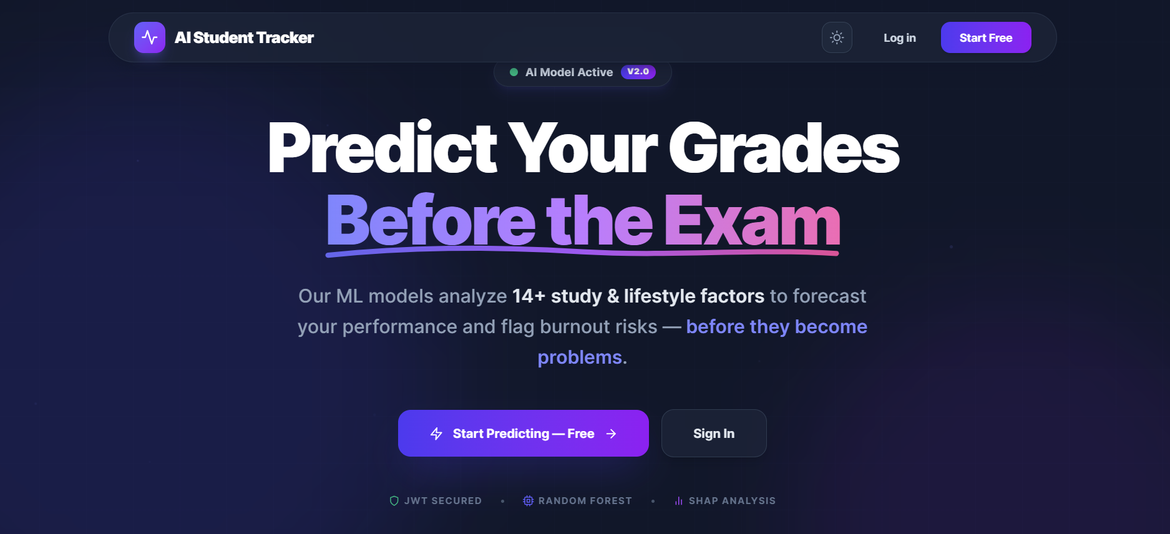

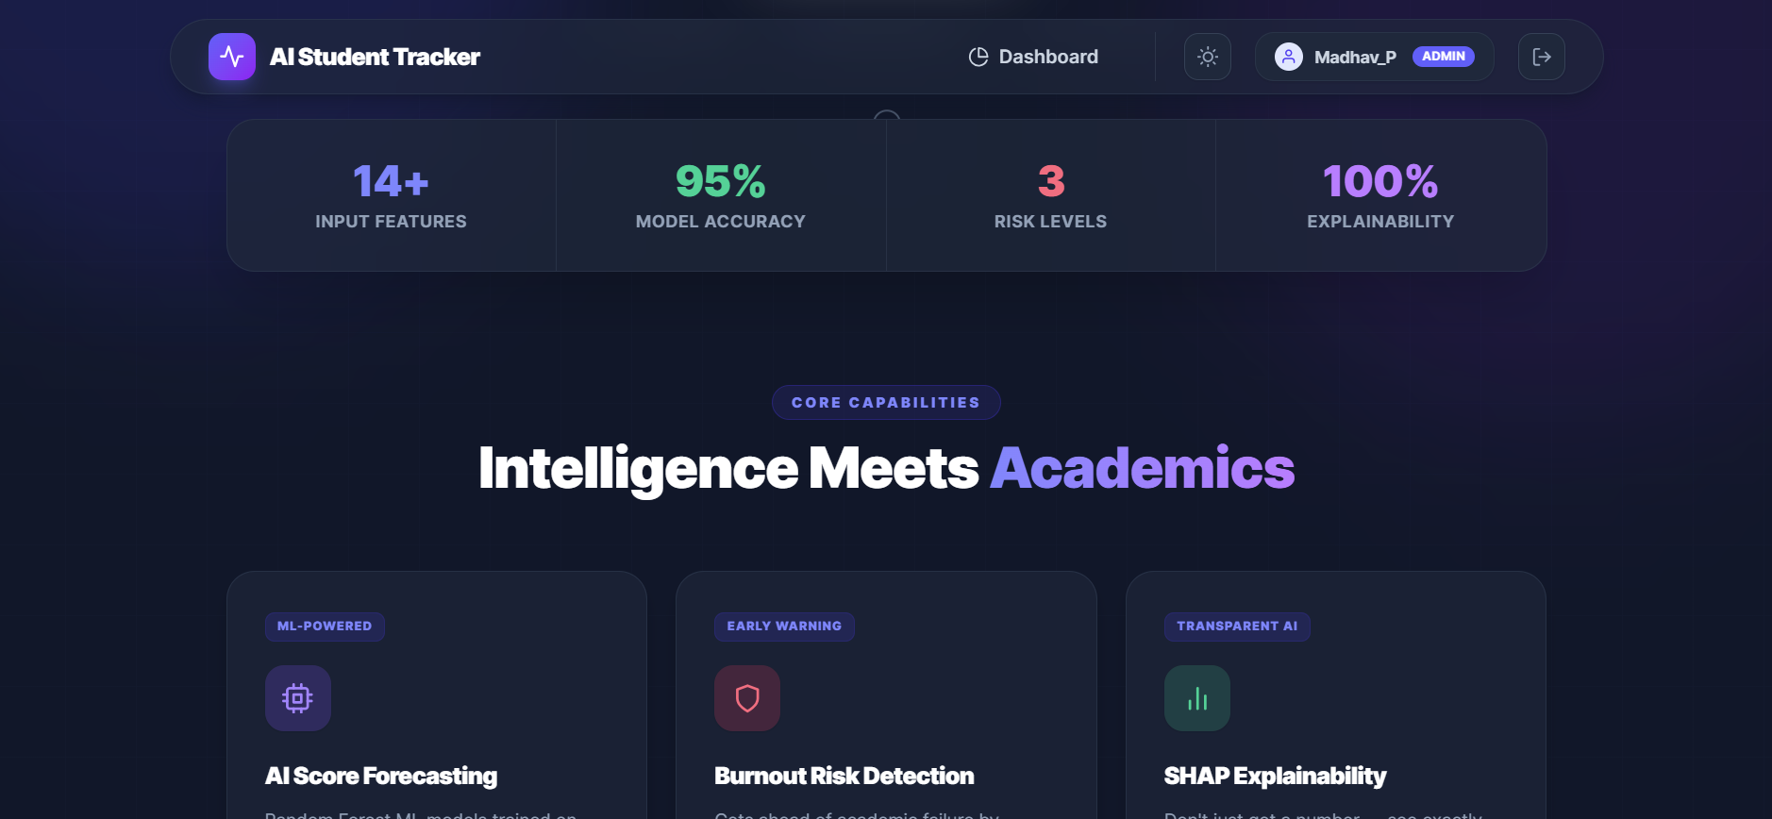

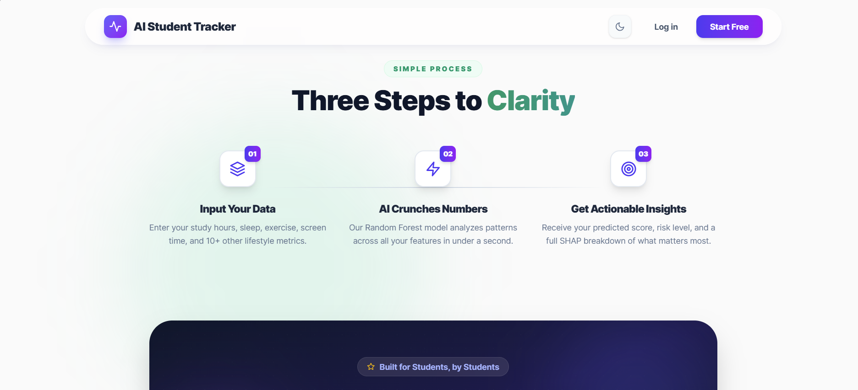

- The Student Dashboard: The layout is split. The top features a large "Score Card" showing the massive numerical prediction. Below it, a Recharts line graph tracks the student's historical trajectory. The right side features the critical "SHAP Impact Graph", breaking down the specific habits causing their current score.

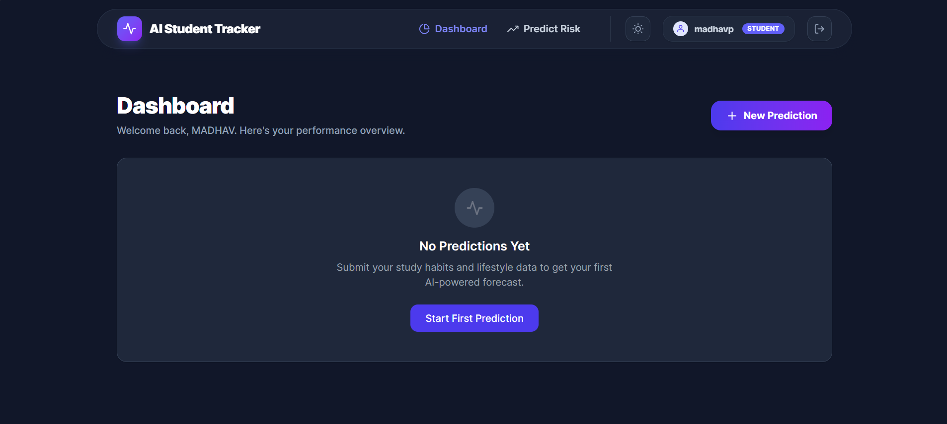

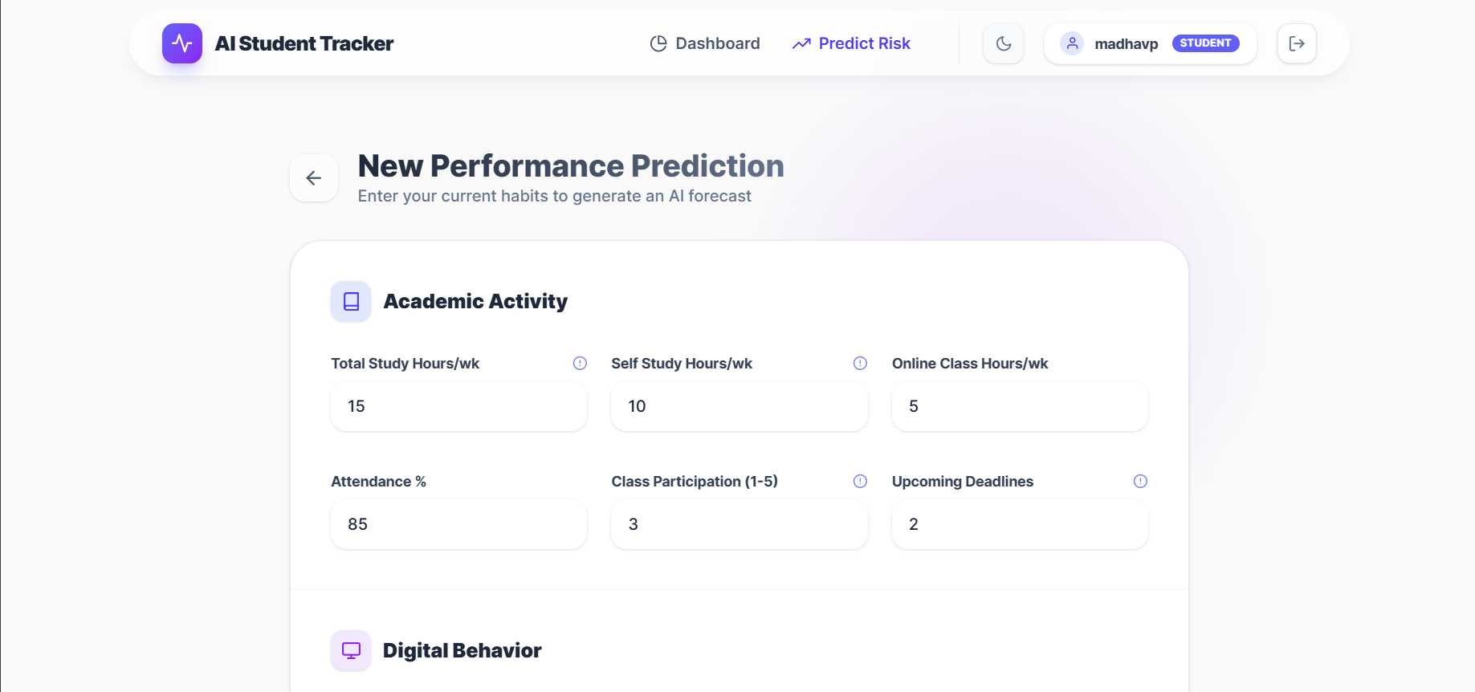

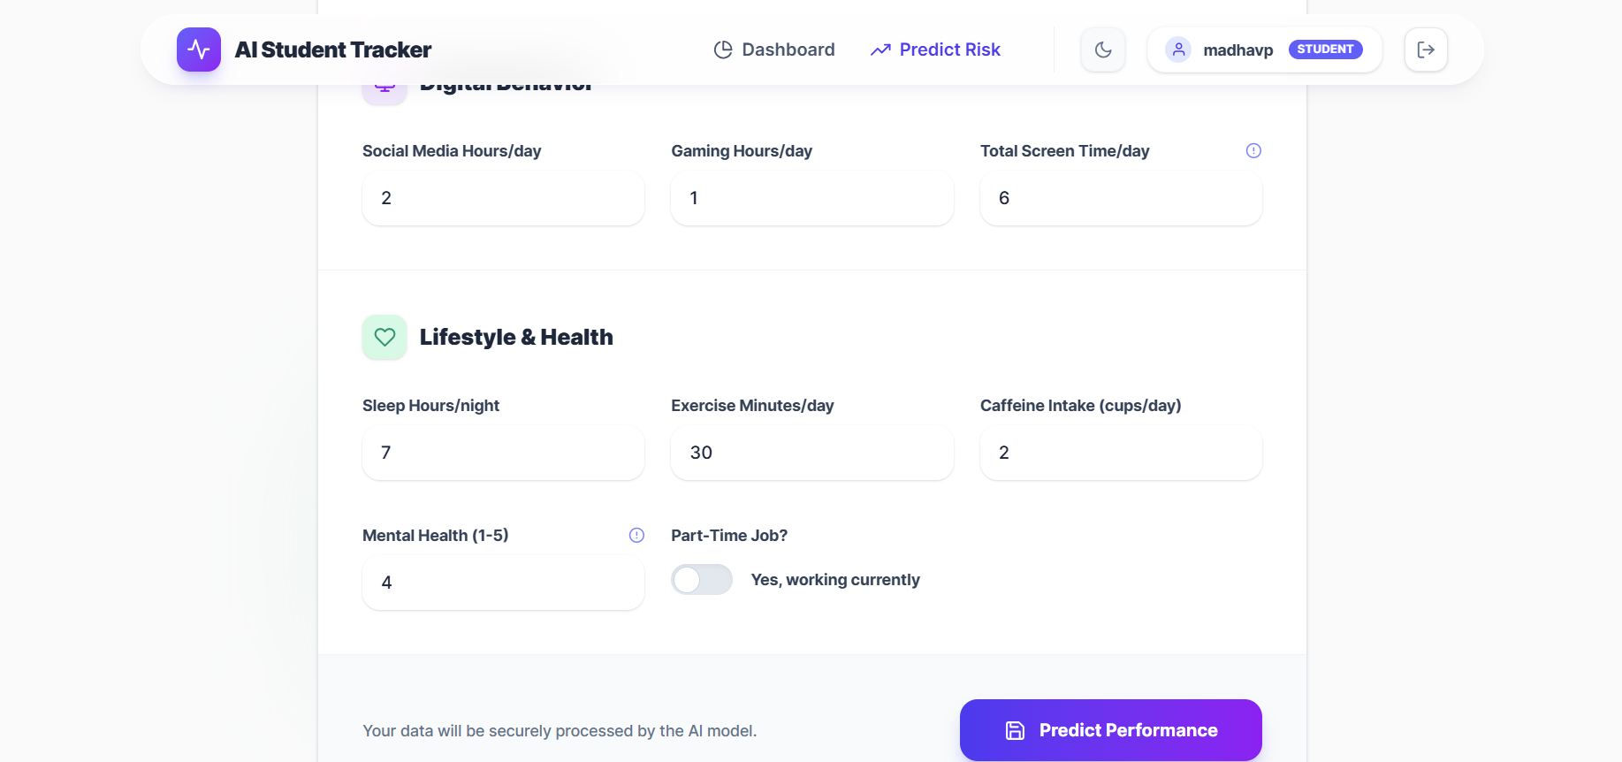

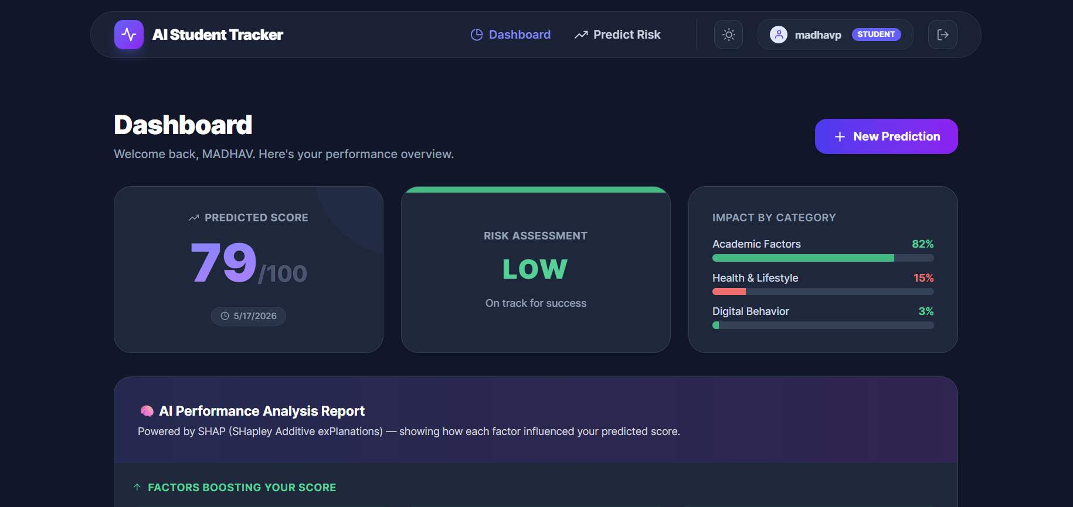

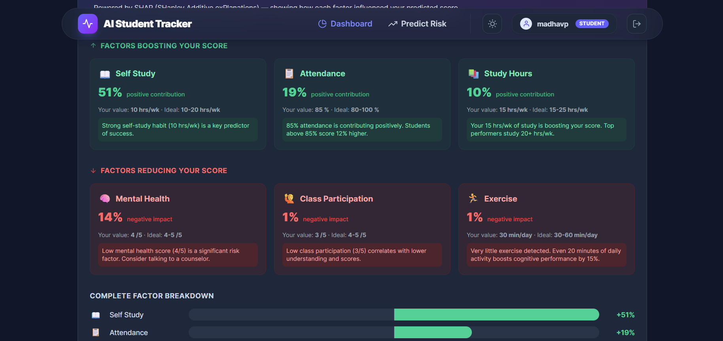

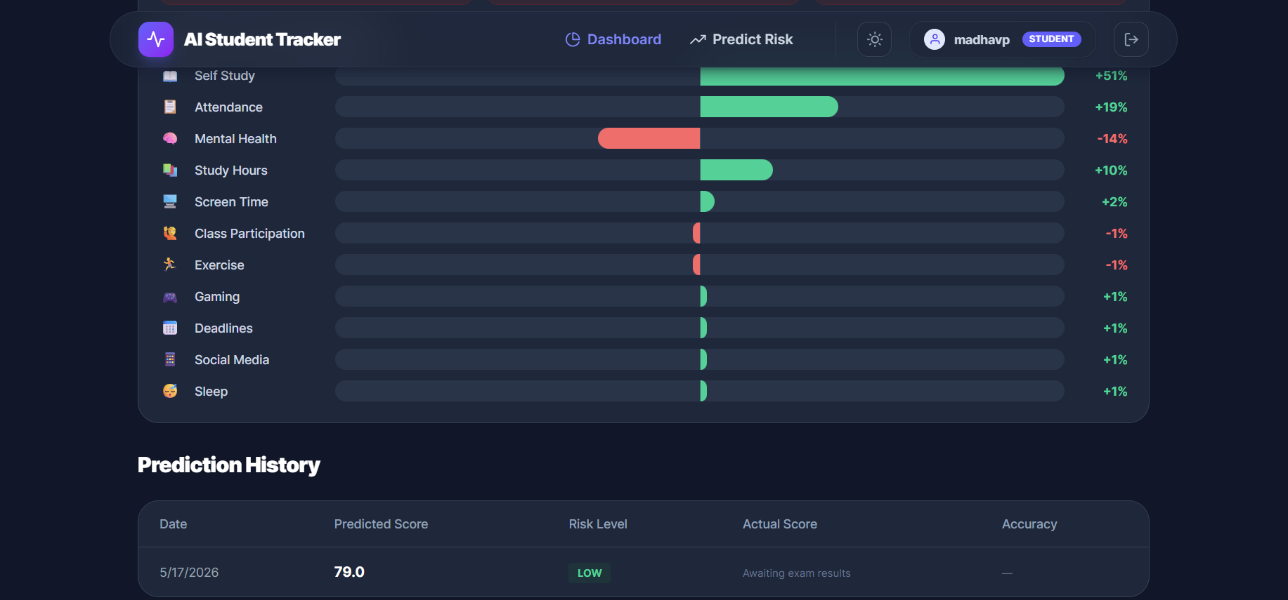

- The Admin Command Center: A full-width data-grid table. It includes complex filtering mechanisms allowing the admin to instantly sort the database of 1000+ students to find the 15 students marked as "High Risk."

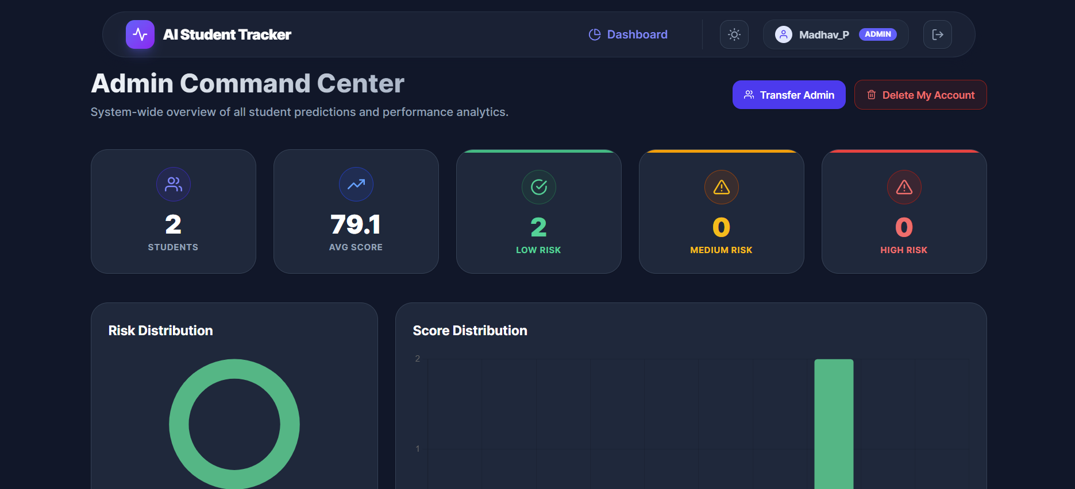

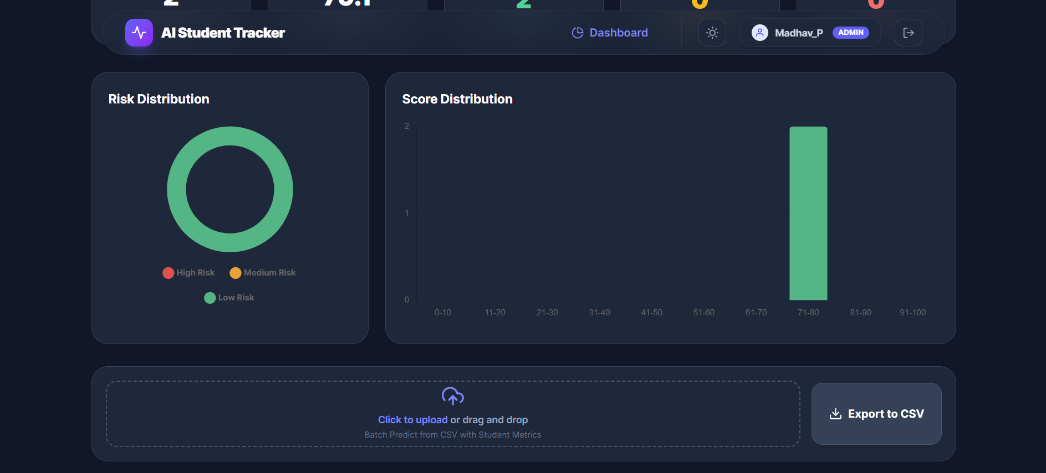

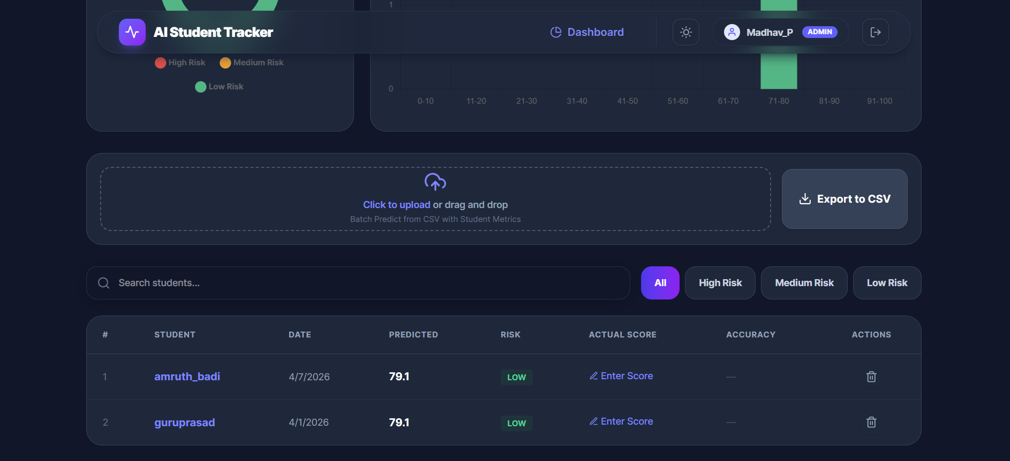

VII. Implementation (Deployment)
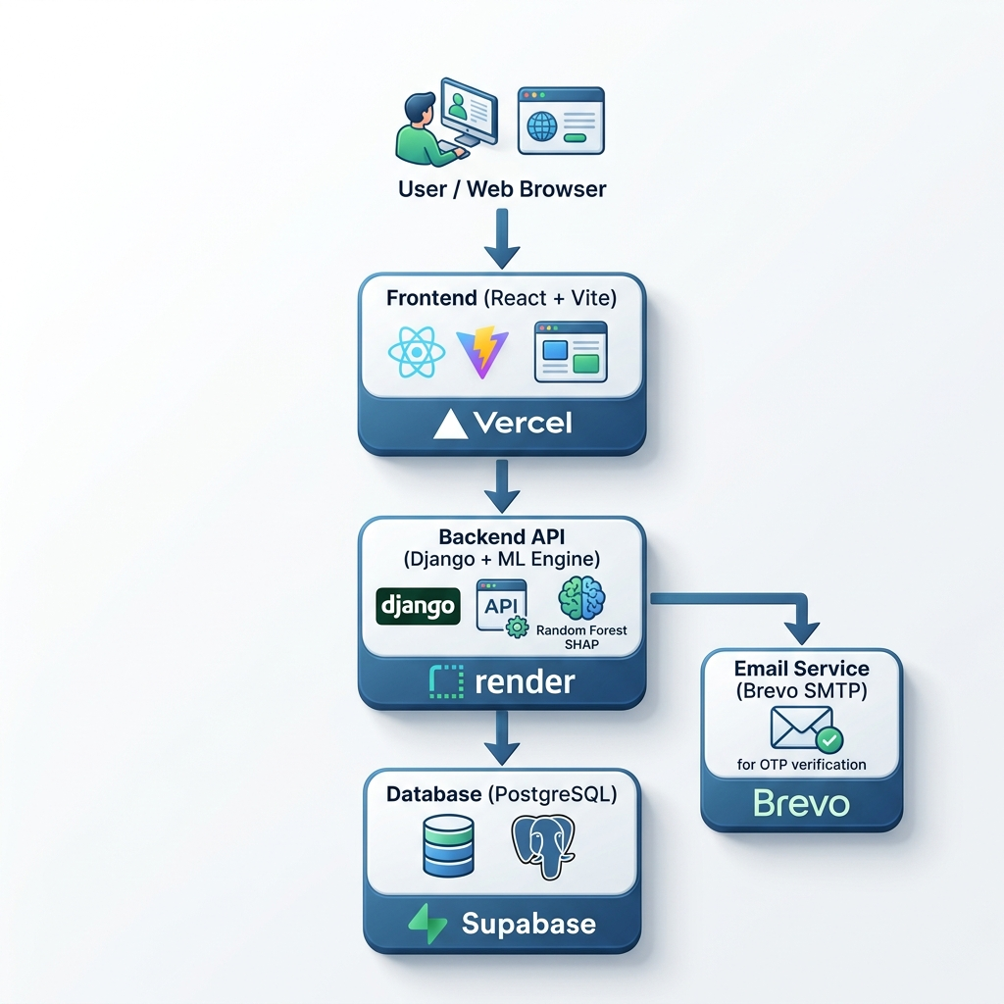

6.1 Backend: Machine Learning Inference Logic
The implementation phase orchestrated the technical transition of our decoupled architecture into a production-grade, cloud-deployed ecosystem.

Backend Architecture :-
To ensure dependency isolation, virtual environments were rigorously enforced across the development lifecycle. We utilized joblib to serialize the optimized Random Forest regressor and classifier models into lightweight persistent files. By natively embedding these within the Django architecture, the system achieves real-time ML inference without relying on high-latency, external proprietary APIs.

(predictions/views.py)

import joblib
import pandas as pd
from rest_framework.views import APIView
from rest_framework.response import Response
from rest_framework import status
from rest_framework.permissions import IsAuthenticated
from students.models import StudentRecord
from .models import Prediction
from .serializers import PredictionSerializer

class RunPredictionView(APIView):
permission_classes = [IsAuthenticated]

def post(self, request, *args, **kwargs):
# 1. Fetch the newly created record ID from the request
record_id = request.data.get('student_record_id')
if not record_id:
return Response({"error": "student_record_id is required"}, status=status.HTTP_400_BAD_REQUEST)

try:
record = StudentRecord.objects.get(id=record_id, user=request.user)
except StudentRecord.DoesNotExist:
return Response({"error": "Record not found"}, status=status.HTTP_404_NOT_FOUND)

# 2. Check if a prediction already exists to prevent duplicate ML runs
if hasattr(record, 'prediction'):
return Response(PredictionSerializer(record.prediction).data, status=status.HTTP_200_OK)

# 3. Load Serialized Machine Learning Models from Disk
try:
rf_regressor = joblib.load('ml_models/rf_regressor.pkl')
rf_classifier = joblib.load('ml_models/rf_classifier.pkl')
explainer = joblib.load('ml_models/shap_explainer.pkl')
except FileNotFoundError:
return Response({"error": "ML Models not found on server."}, status=status.HTTP_500_INTERNAL_SERVER_ERROR)

# 4. Format features into exactly the array the model expects
features = [
record.study_hours,
record.self_study_hours,
record.online_class_hours,
record.attendance_percentage,
record.class_participation,
record.social_media_hours,
record.gaming_hours,
record.total_screen_time,
record.sleep_hours,
record.exercise_minutes,
record.caffeine_intake,
record.mental_health_score,
1 if record.part_time_job else 0,
record.upcoming_deadlines
]

feature_names = [
'study_hours', 'self_study_hours', 'online_class_hours', 'attendance_percentage',
'class_participation', 'social_media_hours', 'gaming_hours', 'total_screen_time',
'sleep_hours', 'exercise_minutes', 'caffeine_intake', 'mental_health_score',
'part_time_job', 'upcoming_deadlines'
]

# Convert to Pandas DataFrame
input_df = pd.DataFrame([features], columns=feature_names)

# 5. Execute ML Predictions
predicted_score = rf_regressor.predict(input_df)[0]
risk_prediction = rf_classifier.predict(input_df)[0]
risk_mapping = {0: 'low', 1: 'medium', 2: 'high'}
risk_level = risk_mapping.get(risk_prediction, 'medium')

# 6. Execute Explainable AI (SHAP) Generation
shap_values = explainer.shap_values(input_df)[0]

feature_explanations = []
for i, name in enumerate(feature_names):
feature_explanations.append({
"feature": name,
"impact": float(shap_values[i]),
"value": features[i]
})

feature_explanations.sort(key=lambda x: abs(x['impact']), reverse=True)

# 7. Persist to Database and Return
prediction = Prediction.objects.create(
student_record=record,
predicted_score=predicted_score,
risk_level=risk_level,
feature_explanations=feature_explanations
)

serializer = PredictionSerializer(prediction)
return Response(serializer.data, status=status.HTTP_201_CREATED)

6.2 Backend: Custom User Model & Email OTP Logic

(core/models.py)

from django.contrib.auth.models import AbstractUser
from django.db import models
from django.utils import timezone
from datetime import timedelta

class User(AbstractUser):
ROLE_CHOICES = (
('student', 'Student'),
('admin', 'Admin/Teacher'),
)
email = models.EmailField(unique=True)
role = models.CharField(max_length=20, choices=ROLE_CHOICES, default='student')
phone = models.CharField(max_length=15, blank=True, null=True)
is_email_verified = models.BooleanField(default=False)

def __str__(self):
return f"{self.username} ({self.role})"

@property
def is_student(self):
return self.role == 'student'

class EmailVerificationOTP(models.Model):
email = models.EmailField()
otp = models.CharField(max_length=6)
created_at = models.DateTimeField(auto_now_add=True)
is_used = models.BooleanField(default=False)

def is_valid(self):
expiry_time = self.created_at + timedelta(minutes=10)
return timezone.now() <= expiry_time and not self.is_used

Frontend Architecture :-

The presentation layer leverages Vite for lightning-fast server startup and near-instantaneous Hot Module Replacement. We engineered Axios interceptor middleware to automatically attach JWT Bearer tokens to outgoing traffic, facilitating secure, stateless communication between the React UI and the Django REST API.

6.3 Frontend: Axios API Service Interceptor
(services/api.js) :-

import axios from 'axios';

const API_URL = import.meta.env.VITE_API_URL || 'http://localhost:8000/api/v1';

const api = axios.create({
baseURL: API_URL,
headers: {
'Content-Type': 'application/json',
},
});

api.interceptors.request.use(
(config) => {
const token = localStorage.getItem('token');
if (token) {
config.headers.Authorization = `Bearer ${token}`;
}
return config;
});

api.interceptors.response.use(
(response) => response,
(error) => {
if (error.response && error.response.status === 401) {
localStorage.removeItem('token');
window.dispatchEvent(new Event('auth-unauthorized'));
}
return Promise.reject(error);
});

export default api;

Cloud Deployment & Infrastructure:

Our multi-cloud orchestration strategy ensures high availability across the stack:

• Database Tier: Managed PostgreSQL persistence hosted via Supabase.

• Backend API: Deployed to Render Web Services utilizing Gunicorn for robust WSGI management.

• Frontend SPA: Optimized delivery via the Vercel Edge Network.

Rigid CORS configurations were established within the Django middleware to permit cross-origin requests exclusively from our verified production domain.

VIII. TEST CASE

The testing phase represents a critical milestone within the development lifecycle, ensuring the platform operates with technical precision under standard operations and diverse edge-case scenarios. Our team executed a multi-tiered validation strategy, including exhaustive Unit, Integration, and User Acceptance Testing (UAT) protocols.

Test ID | Module | Scenario Description | Expected Result | Actual Result | Status
TC-01 | Auth | Register with existing email. | Deny and display error toast. | As Expected | PASS
TC-02 | Auth | Registration with incorrect OTP. | Account remains inactive. | As Expected | PASS
TC-03 | Auth | Login with valid credentials. | Redirect to dashboard. | As Expected | PASS
TC-04 | Security | Direct API endpoint access. | Rejection with HTTP 401 error. | As Expected | PASS
TC-05 | Security | Student accesses Admin portal. | Rejection with HTTP 403 error. | As Expected | PASS
TC-06 | Data Entry | Submission of negative hours. | Blockage via HTML5 validation. | As Expected | PASS
TC-07 | Data Entry | Submission of impossible values. | Frontend trigger blocks input. | As Expected | PASS
TC-08 | ML | Low study + poor mental health. | High Risk classification. | As Expected | PASS
TC-09 | ML | Optimal behavioral metrics. | Low Risk classification. | As Expected | PASS
TC-10 | XAI | Verify SHAP JSON output. | Return feature impact array. | As Expected | PASS
TC-11 | Admin | Admin views dashboard. | Correct rendering of charts. | As Expected | PASS
TC-12 | Admin | Upload invalid file type. | System rejection of file. | As Expected | PASS
TC-13 | Admin | Upload 100-row valid CSV. | 100 inferences processed. | As Expected | PASS
TC-14 | Accuracy | Input actual student score. | Accuracy metric calculated. | As Expected | PASS
TC-15 | UI/UX | User toggles Dark Mode. | Instant theme switch. | As Expected | PASS

Conclusion
The culmination of the AI-Powered Student Performance Tracker signifies a robust technical integration of contemporary full-stack engineering and sophisticated data science methodologies. This research was initiated to confront a systemic vulnerability within educational frameworks: the fundamentally reactive paradigm of traditional scholastic assessment.

Through exhaustive data synthesis, we established that behavioral micro-habits and physiological stability are just as influential to future academic trajectories as conventional metrics like classroom presence. By utilizing Random Forest ensemble learning, we engineered a predictive engine characterized by high reliability. Furthermore, the integration of Explainable AI (SHAP) ensures the architecture remains human-centric, transforming opaque algorithmic outputs into transparent, evidence-based intelligence for proactive academic counseling.

The implementation of a decoupled architecture—synthesizing the secure backend logic of Python/Django with a high-fidelity, Glassmorphism-inspired UI powered by React.js—has produced a production-grade ecosystem that is both highly available and scalable. Ultimately, this dissertation demonstrates that Machine Learning can be leveraged to construct a continuous digital safety net, fostering institutional academic success and mental wellbeing.

Future Enhancement :-
Although the existing framework is technically sound and operational, the architecture was engineered with inherent modularity to facilitate sophisticated subsequent expansions.

1. Automated Celery Task Queues for Real-Time Alerting:

At present, administrative oversight requires manual portal authentication to identify vulnerable cohorts. Future iterations will integrate Redis and Celery to execute background cron operations. Should a learner’s risk trajectory escalate to critical levels over consecutive submissions, the system will automatically dispatch asynchronous SMTP notifications to designated academic counselors.

2. Live WebSocket Integration (Django Channels):

To transform the Admin Command Center into a truly instantaneous interface, Django Channels and WebSockets can be deployed. Upon new data submission, the administrative dashboard will refresh dynamically without browser reloads, functioning with the fluidity of a live ticker.

3. Conversational AI Counseling Chatbot:

Integrating a Large Language Model (LLM) via API would allow the system to interpret SHAP values contextually. If the engine identifies sleep deprivation as a primary driver of academic decline, the chatbot could proactively offer scientific hygiene protocols directly within the student portal.

4. LMS (Learning Management System) API Integration:

Rather than relying strictly on manual habit logging, the platform could interface with APIs from Canvas or Moodle. Automatically harvesting live assessment scores and digital attendance logs would significantly enhance the predictive reliability of the Machine Learning models.

5. Mobile Application Development:

Utilizing React Native to encapsulate the existing logic into native iOS and Android environments would enable students to log routines via push notifications, further fostering academic success through smartphone accessibility.

Bibliography

1. Breiman, L. (2001). "Random Forests". Machine Learning, 45(1), 5-32. (Critical academic reference for the foundational ensemble learning methodologies utilized in this research).

2. Lundberg, S. M., & Lee, S. I. (2017). "A Unified Approach to Interpreting Model Predictions". Advances in Neural Information Processing Systems (NeurIPS) 30. (Primary literature introducing the SHAP framework for algorithmic transparency).

3. Django Software Foundation. (2024). Django Documentation (Version 5.0). Official technical specifications retrieved from https://docs.djangoproject.com/

4. Meta Platforms, Inc. (2024). React Documentation (Version 18). Comprehensive development guides retrieved from https://react.dev/
5. Pedregosa, F., et al. (2011). "Scikit-learn: Machine Learning in Python". Journal of Machine Learning Research, 12, 2825-2830.

6. Qureshi, N. (2023). Student Performance Dataset [Data set]. Kaggle repository retrieved from https://www.kaggle.com/datasets/nabeelqureshitiii/student-performance-dataset

7. Sampath, V. (2024). Ultimate Student Productivity Dataset [Data set]. Kaggle repository retrieved from https://www.kaggle.com/datasets/sampathvinayakbablu/ultimate-student-productivity-dataset

8. Tailwind Labs. (2024). Tailwind CSS Documentation. Utility-first styling specifications retrieved from https://tailwindcss.com/docs

